Cesar Lopez
Dr. Maitner
PCB6455
12/11/25

Coral Reefs and Species Richness

Introduction

Coral reefs are one of the most important habitats on the planet, not only because they are great hot spots for photosynthesis-thanks to the zooxanthellae symbiont, which is a sort of algae that provides coral with nutrients-but also because they help to house several different aquatic species. There have even been surveys conducted by the National Coral Reef Monitoring Program (NCRMP) that have actually kept track of reefs around Florida and their activities—two sets of surveys, to be exact: the Benthic Assessment surveys and the Coral Demographic surveys (NOAA, 2018). Out of the two surveys, the Coral Demographic survey is the one that goes into depth on coral species diversity and density, and that is what prompted the research conducted in this paper. The purpose of this research is to answer one simple, yet very important ecological question, and that is how coral species richness varies throughout different latitudes. It is important to be able to understand this for a couple of reasons. First and foremost, it can help people understand how species richness can vary across different latitudes. More importantly, however, it can help to better understand why there could be more richness in some latitudes than in others, whether it be for resources or for reproduction purposes; for coral specifically, it could help to understand why they choose to grow in certain latitudes as well, whether it be because of the water temperature or the positioning of the reefs. In order to help find the correlation between species richness across varying latitudes, the coding program R will be used to make different linear models with the data that is currently available, and those models will be compared to see which one is the most accurate, allowing for a plot to be made with the more accurate data.

Methods

The methods on how the data was used to find a correlation between species richness and varying latitudes is rather straight forwards. First and foremost, once the data set from NOAA’s surveys was obtained, the data needed to be loaded into R, and the way that was done was by using the application RStudio and making a script that helped to load the data using the read command. Some packages also needed to be loaded into RStudio in order to create models and transformations of the data; the packages used were as follows: “tidyverse,” “ggplot2,” “ggpubr,” “MASS,” and “bbmle.” Once all of the libraries and data were loaded into R, it was time to begin making the models. The first order of business was transforming the data into something that was more easily readable, so that no errors were made trying to make the models. The command sorted everything by group, such as the year, the latitude, the habitat types, etc., and a second line of code was made to further clean up the organized data, removing any “NA” values that may have been present. After the data was better organized, it was time to make the models; two Generalized Linear Models were made to fit the data, and the reason why it was decided to use Generalized Linear Models was because the number of species in the data is considered to be count data, which means that the data is marked down as integers and are greater than zero. Two models were made: A Poisson-based model, and a Negative Binomial model, and in order to figure out which one had the better fit for a plot, an AIC (Akaike Information Criterion) test was performed using the “AICtab” command, which showed that the Negative Binomial model had the better fit, since its “dAIC” value was 0. Finally, it was time to make the plots, and two of them were made. The first was with the transformed data only, and the second was with the Negative Binomial model. It should be noted that prediction data needed to be made for the Negative Binomial model graph. Those two plots showed the relationship between species richness and latitude variation.

Results

The results are not only composed of the graphs that shows the relationship between species richness and latitudes, but they are also composed of the statistical tests and models that were made and conducted throughout the research. It is important to understand what the data for each model constructed looks like, to understand why only one of them had to be used.

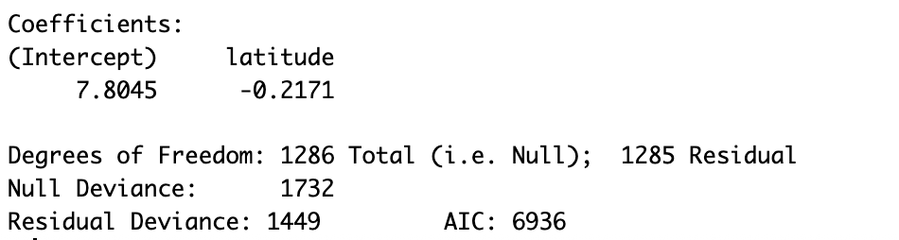
Fig. 1. The data for the Negative Binomial Generalized Linear Model. It shows the degrees of freedom, the null deviance, the residual deviance, and the AIC value, along with the intercept and the latitude.

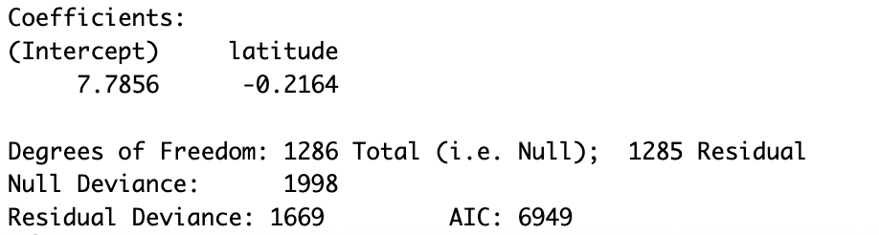
Fig. 2. The data for the Poisson-based Generalized Linear Model. Although similar, some of the values are either larger or smaller than the ones from the Negative Binomial model.

Since both of the models were rather similar to each other, an AIC test was conducted in order to see which of the two models had a better fit. The model with the better fit was then used for the plots, as stated prior. Below are the results of the AIC test.

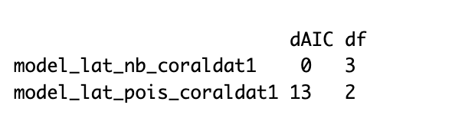
Fig. 3. The AICtab test for the two models. Since the Negative Binomial model had a 0 for the “dAIC” value, it was used over the Poisson-based model, due to it having a better fit.

Two plots were made with ggplot2. The first of the two plots were made using the data after it was initially organized. The second of the two plots were made after the Negative Binomial had been determined to be the better fitting model, so it is a plot based off of that particular model. Both plots are identical to each other in terms of showing the correlation between species richness and latitude.

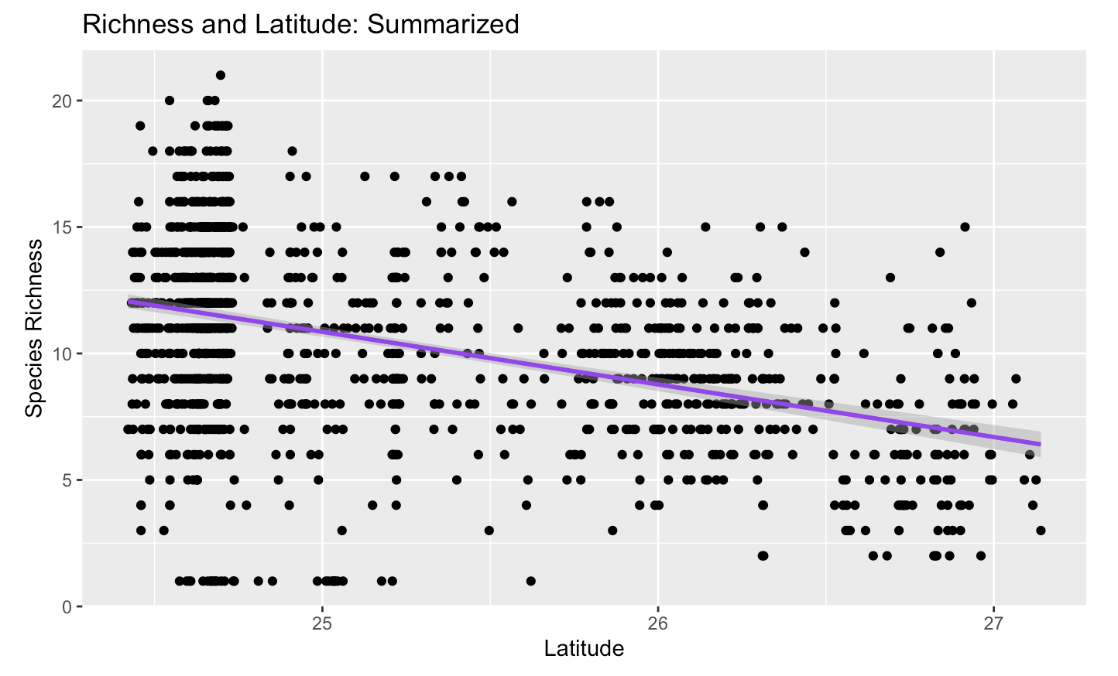
Fig. 4. The graph showing the correlation between species richness and latitude. This was the one made from only the summarized/transformed data. There is a downwards trend that can be seen regarding their correlation.

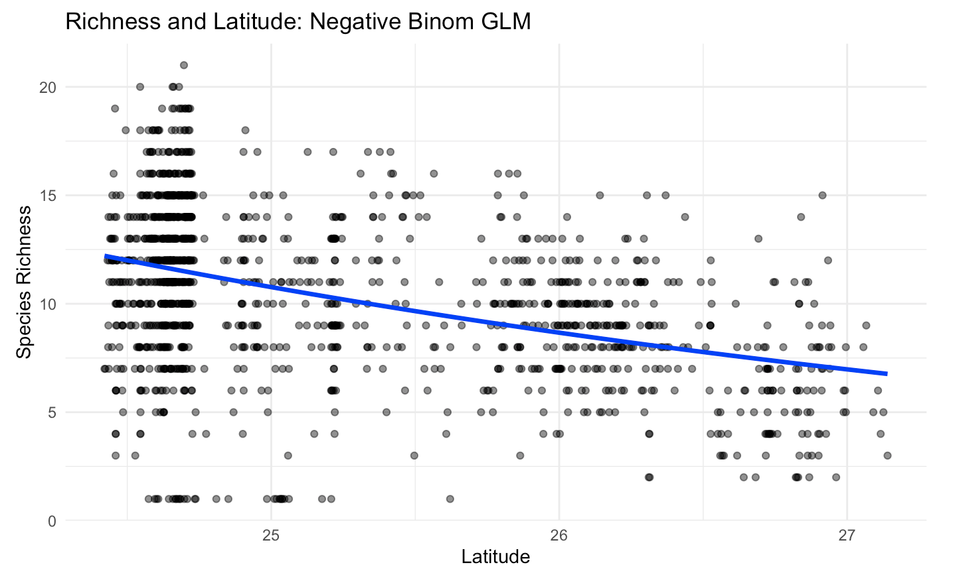
Fig. 5. The second graph showing the correlation between the two. This is the graph that was made from the Negative Binomial model. Most notably, it also shows the density of the species, since some points on the graph are more darkly colored than others.

Both graphs show a downwards trend in species richness in correlation to increasing latitude. At around 25 latitude, it is very densely populated, but as the latitude increases, the species richness becomes more spread out and less abundant. Scientifically, this of course does make sense, since higher latitudes means that it is progressively getting closer and closer to the poles, while decreasing latitudes means that it is getting closer to the equator, and corals do prefer temperate waters over colder or warmer waters—or rather, their sensitivity only allows them to fully thrive in temperate waters, as water that is too cold or too hot for them can cause them to bleach and eventually die off. In conclusion, what was found throughout the research was that as the latitude increases, species richness in corals shows a big decrease, and vice versa. That is the answer to the question that was asked at the start of the paper.

Works Cited

NOAA National Centers for Coastal Ocean Science (NCCOS); Southeast Fisheries Science Center
(SEFSC); University of Miami Rosenstiel School of Marine and Atmospheric Science (UM-RSMAS); Nova Southeastern University (NSU); Florida Fish and Wildlife Conservation Commission (FWC); Florida Department of Environmental Protection (FDEP); National Park Service (NPS); Florida Keys National Marine Sanctuary (FKNMS); Broward and Miami-Dade counties (2018). National Coral Reef Monitoring Program: Assessment of coral communities in the Florida Keys Reef Tract from 2016-05-01 to 2016-12-15 (NCEI Accession 0169401). https://www.ncei.noaa.gov/archive/accession/0169401. In NOAA Southeast Fisheries Science Center; NOAA National Centers for Coastal Ocean Science. National Coral Reef Monitoring Program: Assessment of coral reef benthic communities in the Florida Reef Tract. [indicate subset used]. NOAA National Centers for Environmental Information. Dataset. https://doi.org/10.7289/v5xw4h4z. Accessed December 9th, 2025.

R Core Team (2025). _R: A Language and Environment for Statistical Computing_. R Foundation
for Statistical Computing, Vienna, Austria. <https://www.R-project.org/>.

Wickham H, Averick M, Bryan J, Chang W, McGowan LD, François R, Grolemund G, Hayes A,
Henry L, Hester J, Kuhn M, Pedersen TL, Miller E, Bache SM, Müller K, Ooms J, Robinson D, Seidel DP, Spinu V, Takahashi K, Vaughan D, Wilke C, Woo K, Yutani H (2019). “Welcome to the tidyverse.” _Journal of Open Source Software_, *4*(43), 1686. doi:10.21105/joss.01686 <https://doi.org/10.21105/joss.01686>.

H. Wickham. ggplot2: Elegant Graphics for Data Analysis. Springer-Verlag New York, 2016.

Kassambara A (2025). _ggpubr: 'ggplot2' Based Publication Ready Plots_.
doi:10.32614/CRAN.package.ggpubr <https://doi.org/10.32614/CRAN.package.ggpubr>, R package version 0.6.2, <https://CRAN.R-project.org/package=ggpubr>.

Venables, W. N. & Ripley, B. D. (2002) Modern Applied Statistics with S. Fourth Edition.
Springer, New York. ISBN 0-387-95457-0

Bolker B, R Development Core Team (2023). _bbmle: Tools for General Maximum Likelihood
Estimation_. doi:10.32614/CRAN.package.bbmle <https://doi.org/10.32614/CRAN.package.bbmle>, R package version 1.0.25.1, <https://CRAN.R-project.org/package=bbmle>.

